How to install the CLI for Espros camera

1. Download the code from <https://github.com/lkeithr/tof>
2. Extract the code to a folder of your choice. In my case it is at C:\Users\RUMBAUGHLK\OneDrive - Grove City College\Documents\Research\Time of flight camera\Software\Espros Python\tof so I’m going to use that as an example in the commands below

How to run the CLI for Espros camera

1. Open VS Code
2. Navigate to C:\Users\RUMBAUGHLK\OneDrive - Grove City College\Documents\Research\Time of flight camera\Software\Espros Python\tof
3. Open an integrated terminal
4. Run python .\tof.py -g

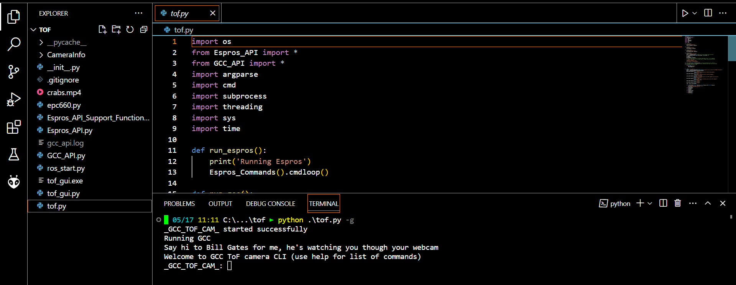

1. At CLI prompt, run the following commands to configure:
   1. disable_illuminators  
      *Turn off the IR illuminators; only green will be used*
   2. set_modulation_frequency 12  
      *Set modulation frequency to 12 MHz*
   3. set_integration_time 4000  
      *Set integration time to 4 ms*
2. Stream data:
   1. Enter stream a
   2. Answer yes
   3. Press spacebar to save images
3. Process data:
   1. As desired
   2. One option: Load data using Matlab using LoadAndPlotTofData